Lesson 02 Demo 10

Inserting Guest Users into the Directory

Objective: To add a guest user into the directory for inviting external (guest) users to the Azure subscription
Tools Required: None

Prerequisites: None

Steps to be followed:
- Add a guest user to the directory

Step 1: Add a guest user to the directory

- Sign in to the Azure portal and go to Azure Active Directory

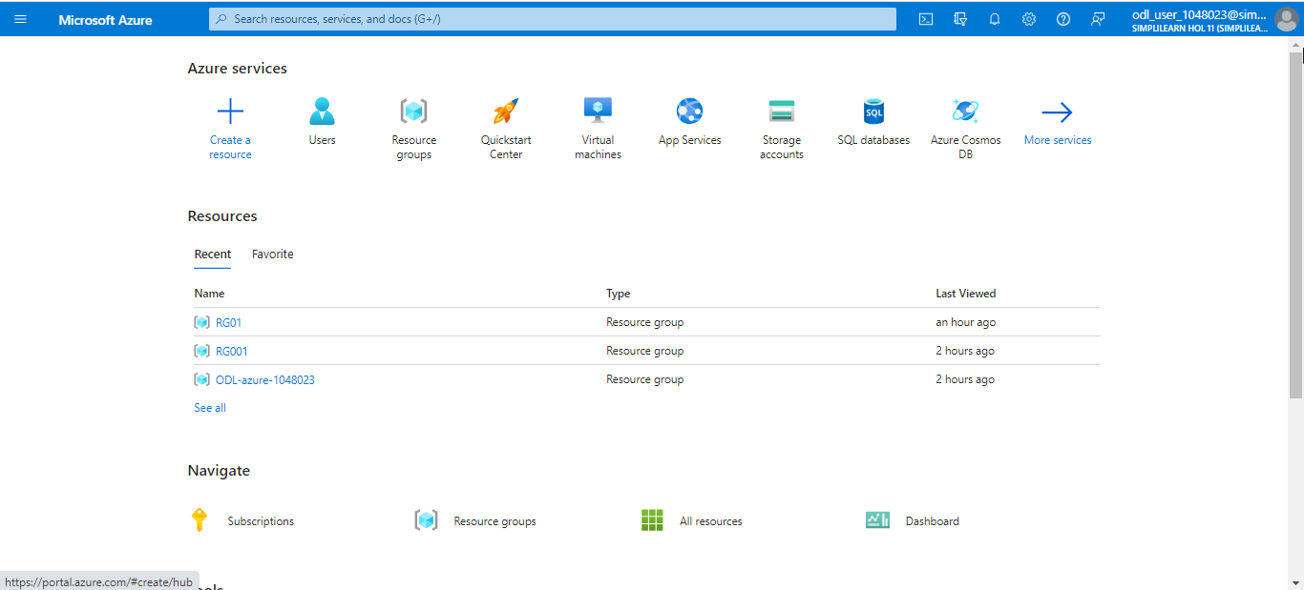

- Click on Administrative units

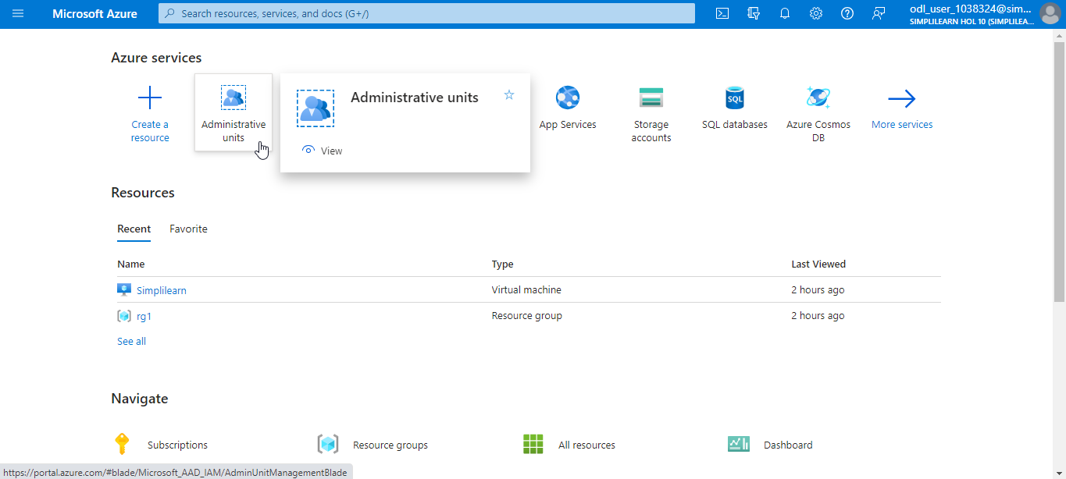

  - Select Users, click on New user, and then select Internal external user

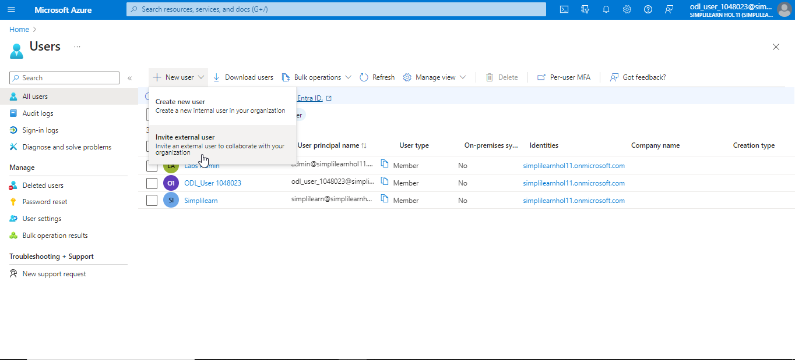

  - Enter the details of the user and click on Review + invite

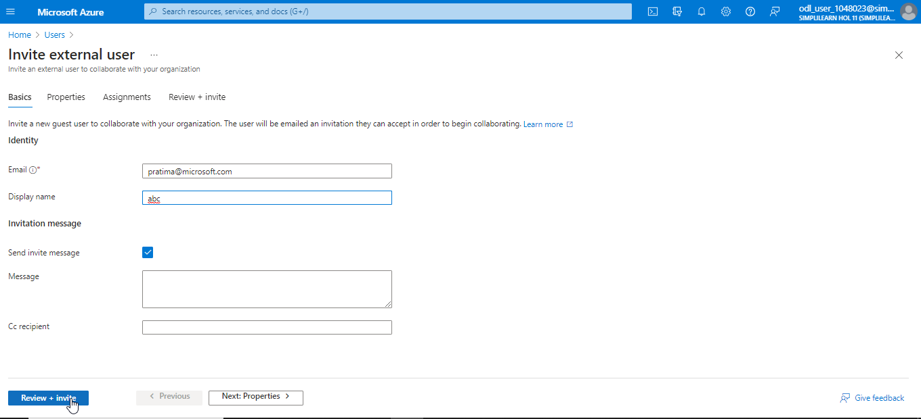

  - Now, click on Invite

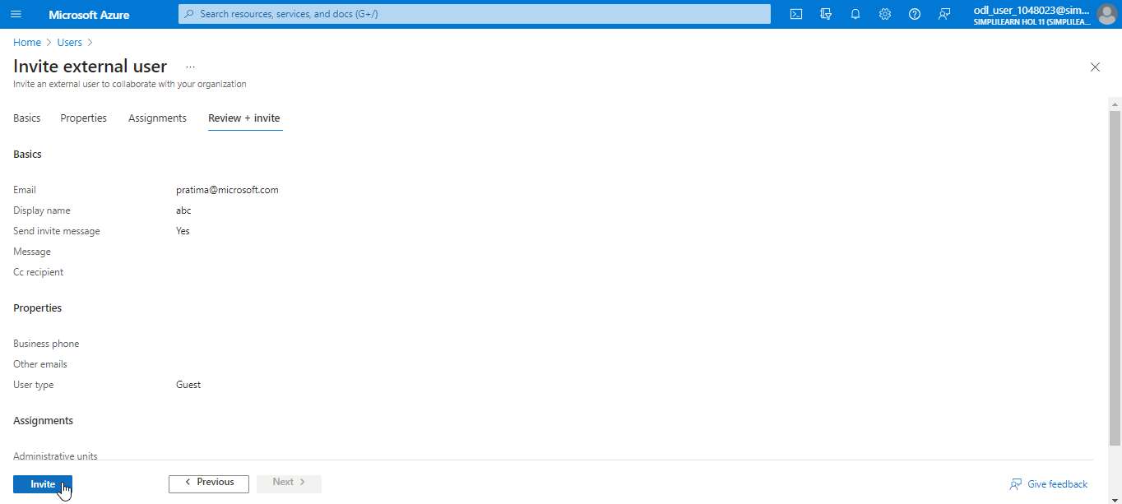

The output is as shown below:

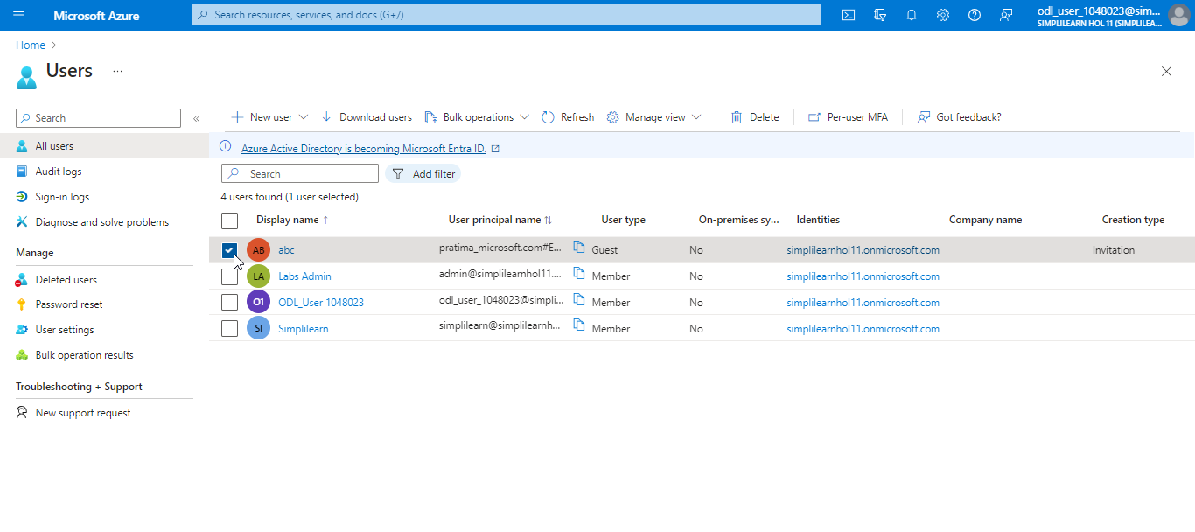

The guest user can click on the Accept invitation link in the invitation email.

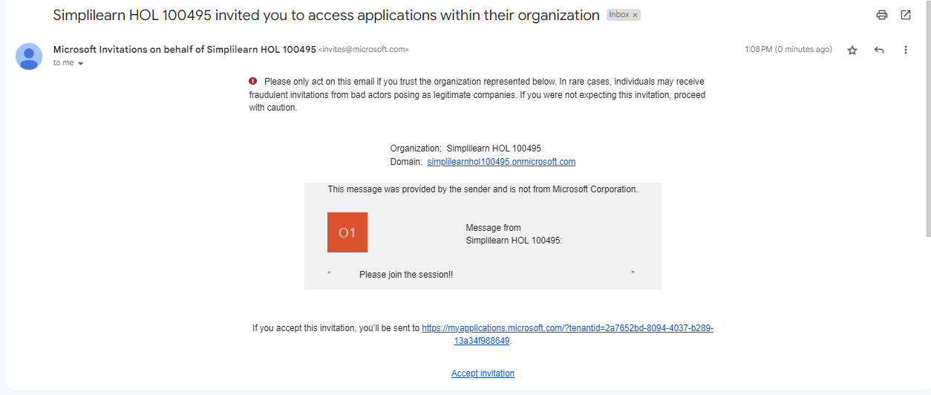

You have now successfully invited external (guest) users to the Azure subscription.

